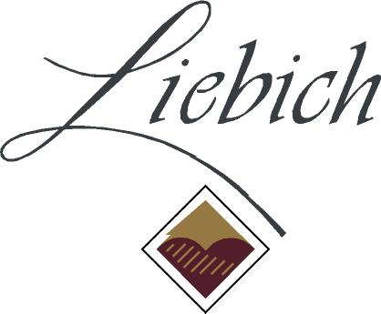
Liebichwein Home Barrel Competition 2018

ENTRY FORM
Date: .........................................
Name.……..…..………………….……………….……………………………………………………………………..………….….....
Contact Phone ………………………….……………………………………..
Email ……………..…………………………….…………………………………………………..……………………………...…………
Postal Address …………………………………………………………………………………..……………………....……………….
Sample approx. age.….…..………………………………………………………….………………...........................……..
Barrel information e.g. size, wood type, source
……………………………………………………………………………………………………………..…………………..............…….
Grape variety or varieties (if known)………....................................................………………………………….
Other sample details
………………………………..……..…………………………………………………………………………………………….……………..
………………………………………………………………………………………………………………………………………………………

HOW TO ENTER
- Entries close September 1st 2018
- Entry fee is $10 per wine (payment on delivery or direct debit can be arranged)
- Each entry must have a separate entry form
- All entries must be minimum 200mL in a well-sealed jar/bottle and secure packaging
- All sample containers must be clearly labelled with your name and contact phone number
- Entry forms and wine samples must be delivered to:
Barrel Competition, PO Box 916 Rowland Flat SA 5352
- Alternatively, samples can be dropped off at Liebichwein during Cellar Door Hours 11-5 Wed-Mon and entry forms can be emailed to janet@liebichwein.com.au

All wines will be judged in a blind tasting by an experience panel. Detailed sample information will not be available to judges during tasting. Results will be announced by the end of September and tasting notes emailed to entrants.
Please call Janet Liebich (08) 8524 4543 or email janet@liebichwein.com.au for more information or help with entries.
www.liebichwein.com.au

