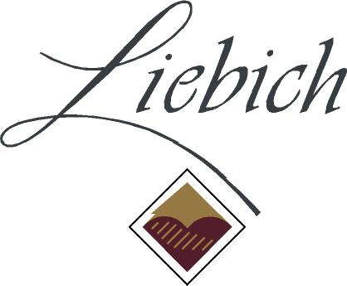
Liebichwein Home Barrel Competition
ENTRY FORM

Date: ............................

Please complete a form for each entry and send along with a well-sealed 200mL sample and $10 entry fee to:
Barrel Competition
PO Box 916
Rowland Flat SA 5352
Alternatively, samples can be dropped off at the winery during Cellar Door Hours.

Name.……..…..………………….……………….……………………………………………….….....

Contact Phone ………………………………………..

Email ……………..…………………………….………………………………………………………………………...…………

Postal Address ………………………………………………………………………………………………....……………….

Sample approx. age.….…..…………………...........................…….. Barrel Size ………..............…….

Grape variety or varieties ……………....................................................………………………………….

Other sample details ……………………..……..…………………………………………………………………………..

ENTRIES DUE 1st JULY 2015
RESULTS ANNOUNCED 26th JULY 2015
www.liebichwein.com.au

Please call (08) 85244543 or email info@liebichwein.com.au for more information

